PERSONAL DETAILS
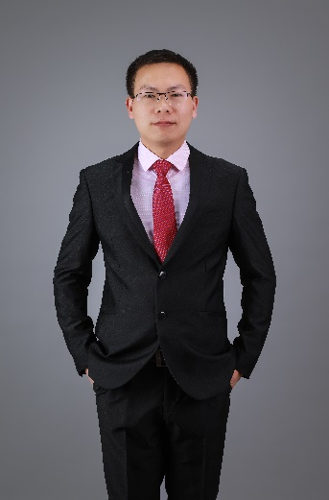 | Full Name | Peng Wang
 | Gender | Male
 | Designation | Lecturer
 | Department | College of Engineering
 | Institution/Organization | Huazhong Agricultural University
 | Qualification | Doctor
 | Area of Specialization | Materials Science
 | Sub Division | Metallic Glass
 | DOB
 | DOJ
 | Total Experience
 | Mobile Number | +86-15271811351
 | Email | wangp@mail.hzau.edu.cn
About your Education, Experience and Academic achievements (200 words)

Education:
Degree | Year | University | Major
Ph.D. | 2017 | Huazhong University of Science and Technology | Solid mechanics
B.S. | 2011 | Huazhong University of Science and Technology | Engineering mechanics

Experience:
2017-Present: Lecturer, College of Engineering, Huazhong Agricultural University

Academic achievements:
2015, The Excellent Postgraduate Cadre
2014, The Knowledge and Action Scholarship
2012, The Merit Postgraduate Student
2011, The Outstanding Graduates
2010, The Encouragement Scholarship
2007, The Freshman Scholarship

RESEARCH, INNOVATIONS AND EXTENSION
Question | Nos. | Question | Nos.
No. of Research Project Completed and On Going | 5 | Citation index in Scopus/ Web of Science or PubMed/ Indian Citation Index | 31
No. of Consultancy and Industries Sponsored Projects |  | No. of Books Published with ISBN  (Text, Reference, Chapters and Conference Proceedings)
Total cost of the all Projects in USD/INR | $324114 | No. of Patent Published and Under Process
No. of Journals Published in SCI and SCIE index | 8 | No. of Editorial Appointments in Journals/ Conferences (Editor, Reviewer and Member)
No. of Journals Published in Scopus, Web of Science and PubMed index | 8 | No of Countries Visited for research activities
No. of Journals Published in Other index | 2 | No. of Research scholar Graduated
No. of Conference Presentation | 6 | No. of Research scholar On Going
Cumulative impact factor of the last 3 years | 7.776 | No. Invited Speaker/ Resource person
H-index: Bibliometrics of the publications based on Scopus/ Web of Science. | 3 | No. of Research Conference/workshop Organized
Total number of Collaborative activities for research: (Joint publication/Project) |  | Total number of awards and recognition received
Number of functional MoUs with other universities/ industries/ corporate. |  | No. of Member of Professional Bodies:
Areas of Research | Mechanical behaviors and deformation mechanisms of materials
About your contribution towards the Research & Development, Innovations, and Extension Activities (200 words)

Title: Atomistic investigation of aging and rejuvenation in CuZr metallic glass under cyclic loading
Abstract: The structural evolution and mechanical response of CuZr metallic glass (MG) under cyclic loading are investigated by molecular dynamics simulations. Either aging or rejuvenation was observed in the MG under cyclic loading with different cyclic strain amplitudes. Aging is more remarkable in the surface, while rejuvenation is correlated with the nucleation and development of shear transformation zone in the bulk of MG. The MG models with more structural heterogeneity were prepared by increasing the cooling rate during cooling process to exhibit larger degrees of structural evolution and aging during cyclic loading. While the fraction of ordered coordination polyhedron increases monotonically with increasing Cu content, the degree of aging during cyclic loading is not significantly impacted by Cu content. The glass-forming ability is the intrinsic character that governs the change in energy state and structural evolution of MG under cyclic loading. The critical cyclic strain amplitude for the transition from aging to rejuvenation is closely related to the initial structure of MG.
https://www.sciencedirect.com/science/article/abs/pii/S0927025620304560

PERSONAL/ RESEARCH PROOFS, CATEGORY OF AWARD AND DECLARATION

Google scholar link
(Publication Proof)
Scopus link
(Publication Proof)
Linkedin link
(Publication Proof)
Researchgate link  (Publication Proof) | https://www.researchgate.net/profile/Wang_Peng19
Institute ID Link/Upload/Number
(Working Proof)
Certificate Links/Upload/Number
(Education Proof of Last degree)
Passport/ Govt. ID Links/Upload/ Number (Age Proof)
Personal website link
Tick the Suitable award category | - Distinguished Scientist Award  - Young Scientist Award  - Life time achievement Award  - Outstanding scientist award  - Women Research Award  - Best Researcher Award  - Best Innovation Award | - Best Faculty Award  - Best Research Scholar Award  - Excellence in Innovation  - Excellence in Research  - Excellence Award (Any Scientific field)  Best Research Award.
Self Declaration
I authenticate that to the best of my knowledge, the information given in this form is correct and complete. At any time I am found to have concealed any material information, my application shall be liable to be summarily terminated without notice. I have read the terms and conditions and other policies of the International Research Awards and agree to stand the same. I agree to Pencis to process the data submitted in this application form, or any other data that the Foundation may obtain from me for any purposes connected with Pencis for any other legitimate reason. The filled applications along with duly completed curriculum vitae, Pass port size photograph, Scan copy of the degree Certificate, Scan copy of the Working ID and related documents should be Upload in website/ sent via email to : contact@pencis.com

Date : Aug 6, 2020 Place : Huazhong Agricultural University Scanned Signature of Applicant: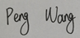

Office Use only

Decision | Reason | Signature of authorities | Date
Selected/Rejected

